**Steps to Upload Artifactory to Jfrog**

* Login to Jfrog website using your Gmail account.
* Click on the profile and select the option: Quick Repository Creation.
* Select the package type(s) you want to **Create Repositories ( Maven).**

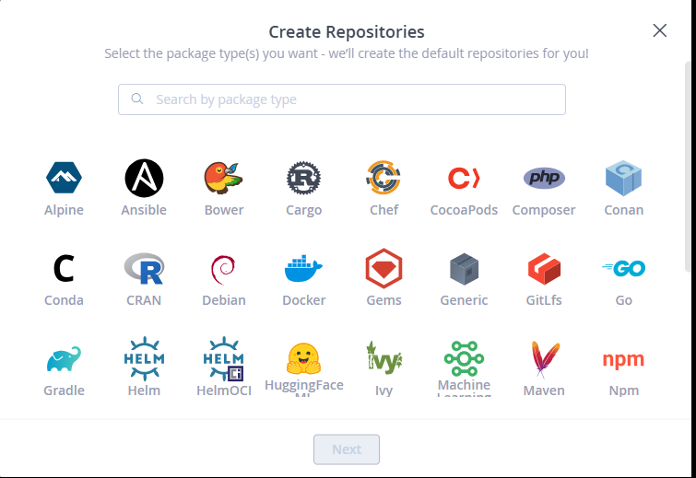

* Click on Next and give your project name under : Repositories prefix (hello_world_war), then click create.

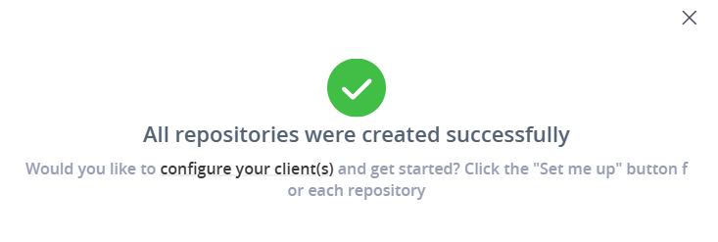

* Click on configure your clients.
* Click on the “Set Me up” option.  
  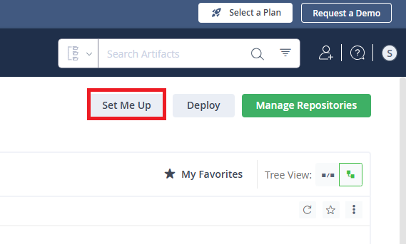
* Under “**Configure”>** Generate token

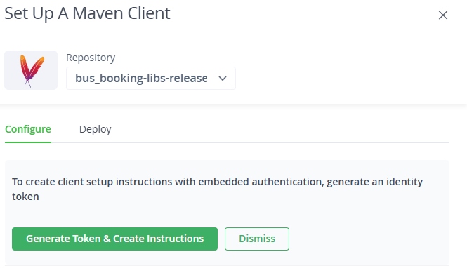

* Under “Deploy” copy the code and paste it over the pom.xml file of your project.

Ex: <distributionManagement>

<repository>

<id>central</id>

<name>a0ljrs4qtn9sm-artifactory-primary-0-releases</name>

<url>https://trialn9a7h3.jfrog.io/artifactory/bus_booking-libs-release</url>

</repository>

</distributionManagement>

* Ensure Id and other details are updated as per the projects.

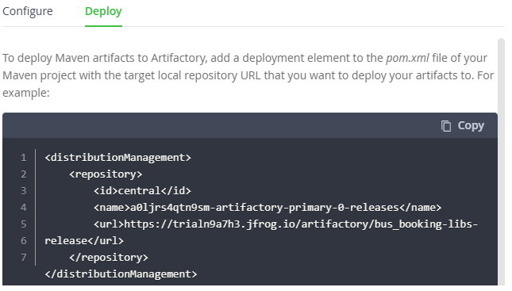

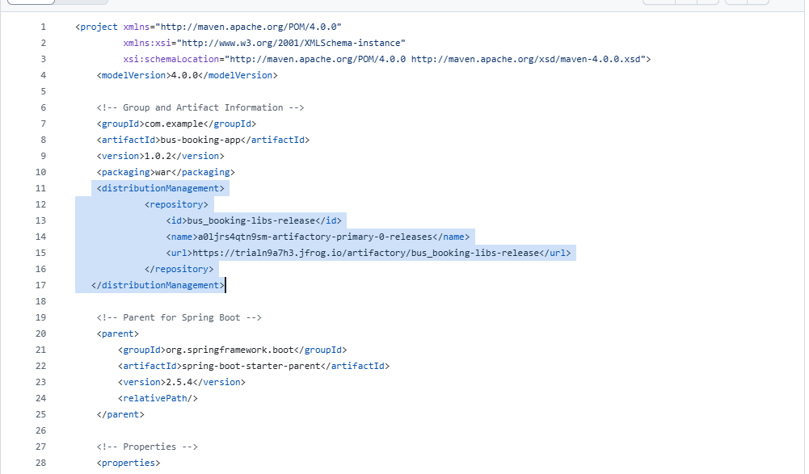

* Update the below code in settings.xml file under root path where the maven is installed, that is .m2 folder.

<settings>

<servers>

<server>

<id>bus_booking-libs-release</id> <!-- This ID must match the one in your pom.xml -->

<username>Username</username> <!-- Replace with your JFrog Artifactory username -->

<password>Jfrog Token </password> <!-- Use the API key here instead of your password -->

</server>

</servers>

</settings>

* Then run maven using code to build your project using the below comments: mvn clean install.
* Then run “mvn deploy”.

--------------------Working Curl Download Syntax----------------------------

curl -L -u "username:key" -O "https://trialvvjw1c.jfrog.io/artifactory/my-hello-world-new-libs-snapshot-local/com/jfrog/my-jfrog-app/my-parcel-service-war-5.war"

to upload:

curl -u "${{ secrets.ARTIFACTORY_USERNAME }}:${{ secrets.ARTIFACTORY_API_KEY }}" -T "target/hello-world-war-1.0.0.war" "https://trialvvjw1c.jfrog.io/artifactory/new-hello-world-war-libs-snapshot/com/jfrog/my-jfrog-app/hello-world-war-${{ github.run_number }}.war

* Update the version tag in pom.xml file with the below details to update the new versions for every project run.

<version>1.0.${env.GITHUB_RUN_NUMBER}</version>

* Files will be uploaded to Jfrog with all the above steps and we can view the project [Artifactory](https://trialn9a7h3.jfrog.io/ui/) file as below

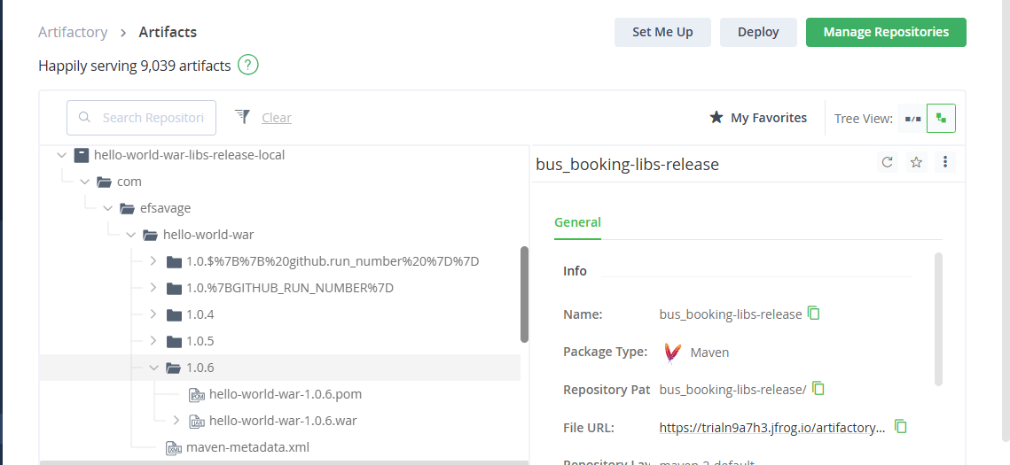

* To run the jobs as Git actions > Go to the settings and Select Secrets and variables > Actions.

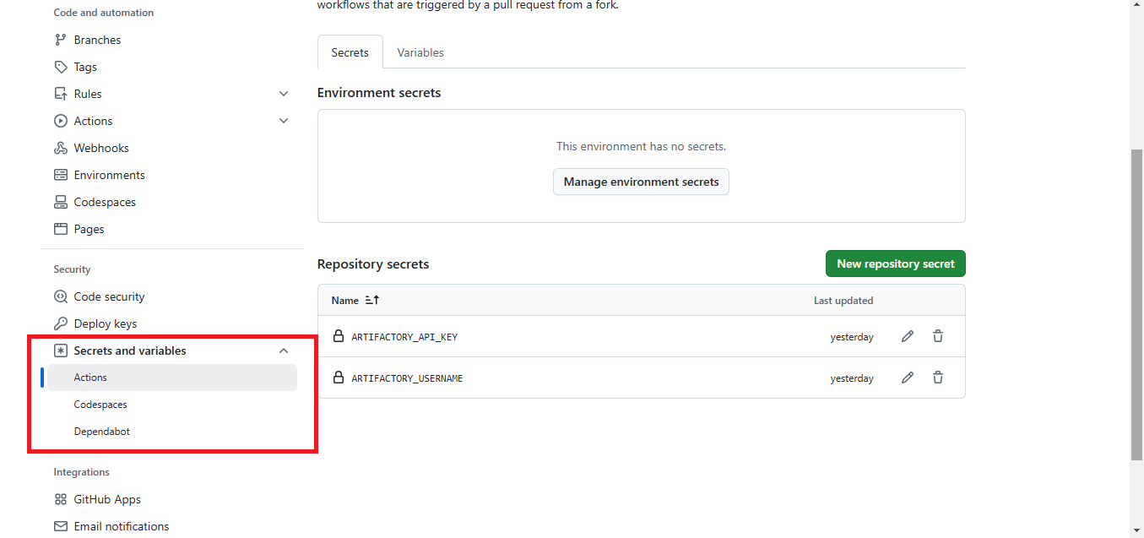

* Select “New repository secret” and add your ARTIFACTORY_USERNAME and ARTIFACTORY_API_KEY.
* Go to github/workflows folder and update maven.yml with below code

- name: Configure Maven settings

run: |

mkdir -p ~/.m2

echo "<settings>

<servers>

<server>

<id>hello-world-war</id>

<username>${{ secrets.ARTIFACTORY_USERNAME }}</username>

<password>${{ secrets.ARTIFACTORY_API_KEY }}</password>

</server>

</servers>

</settings>" > ~/.m2/settings.xml

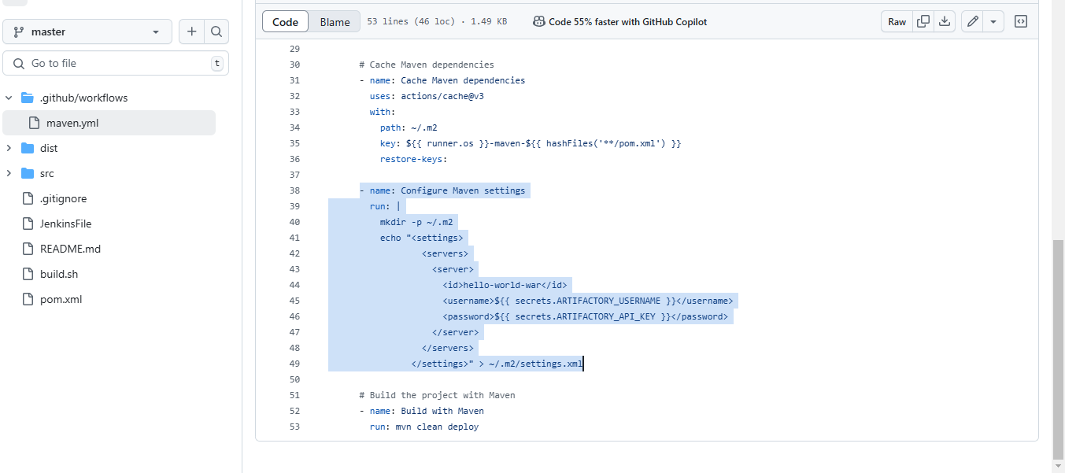

* Whenever you commit the changes in code. Then we can see the job running in Git hub action as below

